**Account Management System**

**Software Requirements Specification Document**

Name: Chebrolu Rukmini

RollNo: AP18110010298

Sec: CSE-E

**1.Introduction**

**1.1 Abstract**

The Account Management System is an application for maintaining a person’s account in a bank. This application shows the working of a banking account system and covers the basic functionality of an Account Management System. To develop a project for solving financial applications of a customer in a banking environment to nurture the needs of an end banking user by providing various ways to perform banking tasks. This project is developed using JSP, Java, MYSQL for storing databases and html CSS for basic stylings. The system is easy to use and interactive for customers. Thus, the features of this project will save transaction time and therefore increase the efficiency.

**1.2 Purpose**

The main aim of designing and developing this banking system is to provide secure and efficient net banking facilities to the banking customers over the internet. Storing Transactions and Account details and all like withdraw deposit and all will be easier to store in database and can access easily by bank admin. Every time the user needs to perform some transactions he has to go to the bank and perform the necessary actions, which may not be so feasible all the time. Here, we provide automation for the banking system through the internet. This project gives real life understanding of the Online Banking System and activities performed by various roles in the supply chain.

**1.3 Intended audience and reading suggestions**

This document is mainly intended for the people who are involved in the development, testing, operation, maintenance, and quality assurance of the system. This also helps users and clients in understanding the requirements of the system. Audiences need not follow any particular order while reading the document and they are free to move to any section which they find relevant to them

**1.4 Project Scope**

This is Java programming-based application where the admin can easily get the details of customer accounts, and can create new accounts for customers, and verify the new accounts of customers and approve them if details are validated and verified correctly. There are 2 entities Customer and Admin. Customers can easily see their account details once logged in successfully and check the summary of transactions, easily transfer money from one account to another, they can check balance whenever they want, and can withdraw and deposit their money in account via Admin. And the admin can view all the databases of individual customers.

**1.5 Definitions, Acronyms, and Abbreviations**

SRS - Software Requirements Specification

AMS- Account Management System

**1.6 Overview**

This project is developed to nurture the needs of a user in a banking sector by embedding all the tasks of transactions taking place in a bank. Online banking is an innovative tool that is fast becoming a necessity. If properly maintained this is very much beneficial.

**2. Overall Description**

**2.1 Product Perspective**

The Account Management System would be a Java-Web Application, through which customer can easily create/open new account, can easily deposit amount, withdraw money from their own account,

Customers can easily transfer money from one account to another account. They can easily check the balance, customers can request the admin to delete their account, and customers can see their own details easily. Admin can easily accept the customer’s request, and can approve customers’ accounts, and can deny and delete the customers’ accounts.

**2.1.1 Hardware Interfaces**

Operating system: Windows/ Linux/ Mac/ any other

Processor: i3 or above

Hard Disk Space: 124MB (min) for JRE

RAM Memory: 128MB (Min)

JRE System Library need to import in Eclipse IDE

Maven Dependencies

**2.1.2 Software Interfaces**

IDE: Sublime text/Notepad

Eclipse IDE - for writing and running code

Apache Tomcat Server

MySQL Workbench for Database

Browser: Google chrome or Mozilla Firefox or Internet explorer or Microsoft Edge etc.

**2.2 Product Features and Characteristics**

The Account management system provides the functionalities for the admin and customers

Such as:

**Admin:**

1. First needs to login to the admin page
2. Admin should be able to accept the customers new account requests and approve the details
3. Can able to delete and deny customers’ requests

**Customers:**

1. Customers need to login to their account if already existing account otherwise needs to open new account
2. Customers can deposit amount after login to their account
3. Customers can withdraw amount whenever required
4. They can easily transfer amount from one to another account in online easily
5. They can check the balance

**2.3 Operating Environment**

Below mentioned are the modules with their description which we have used in our project:

**HTML**: HTML (Hypertext Markup Language) is the most basic building block of the Web. It defines the meaning and structure of web content. Every web page you see on the Internet is written using one version of HTML code or another.

**CSS:** Cascading Style Sheets (CSS) is a simple mechanism for adding styles (e.g., fonts, colors, spacing) to Web documents. CSS defines how HTML elements are to be presented on screen, paper, or in other media. CSS saves a lot of work

**MySQL:** MySQL is a relational database management system based on SQL – Structured Query Language. The most common use for MySQL, however, is for the purpose of a web database.

**Java:** Java is a class-based, object-oriented programming language and is designed to have as few implementation dependencies as possible. A general-purpose programming language made for developers to write once run anywhere that is compiled java code can run on all platforms that support java. Java applications are compiled to bytecode that can run on any Java Virtual Machine.

**JSP:** Java Server Pages is a Java standard technology that enables you to write dynamic, data-driven pages for your Java web applications.

**3.** **SYSTEM FEATURES**

# **3.1** FUNCTIONAL **REQUIREMENTS:**

This is how the application will appear and function until it has been successfully completed. The functional criteria must be met by the system are as follows:

1. **Home Page -** This is welcome page of the banking system here we can find menu like admin Login, Customer Login and all
2. **Login Page -** After entering to the login page customer can be able to login if the account is already existing otherwise there is another option for creating an account.
3. **Create/Open New Account -** Then he or she can be able to create a new account by filling all the valid details and then that request will be sent to the admin automatically, the admin will verify and then if details are correct then admin will give the access to the customer otherwise deny.
4. **Admin Screen -** After the admin has successfully logged in, he is able to view all the customer details like accounts, balance transactions and all and can approve the new customer accounts and can delete the account if a customer given a request to delete.
5. **Customer Screen -** After successfully logged in, customer can be able to see the summary of account and then make transactions from one to one, can deposit money, with draw money and can view transaction summary

# **3.2** NON**-FUNCTIONAL REQUIREMENTS:**

A non-functional requirement is a requirement that specifies criteria that can be used to judge the operation of a system, rather than specific behaviors. Some of the non-functional requirements include:

● There should be sufficient network bandwidth

● Backup- provision for data backup

● Easy to maintain

● Performance/ response time- fast response

● Usability by target user community- easy to use

● Expandability- needs to be future proof or upgradable

● Safety- should be safe to use

**3.2.1 PERFORMANCE REQUIREMENTS:**

Performance requirements define acceptable response times for system functionality.

* Performance should be fast
* Performance will depend up on hardware components
* The load time for user interface screens shall take no longer than two seconds.
* The log in information shall be verified within five seconds.
* Queries shall return results within five seconds.

**3.2.2** **SAFETY REQUIREMENTS**

**●** Data in the database of the system should not be lost or damaged.

**●** The source code developed for this system shall be maintained in the configuration Management tool.

**●** If there is extensive damage to a wide portion of the database due to some failure, such as a disk crash, the recovery method restores a past copy of the database that was backed up to archival storage and reconstructs a more current state by reapplying or redoing the operations of committed transactions from the backed-up log, up to the time of failure.

**3.2.3** SECURITY **REQUIREMENTS**

* Secure access of confidential data. (Customer information)
* The whole system is secured. Only the admin can access all the databases at any time.

**3.2.4** SOFTWARE **QUALITY ATTRIBUTES**

**Availability:**

The online account management system will be available to users at any time except when the server is lost or has a bad internet connection or when having some errors.

**Robustness:**

If the connection between admin and the customer is broken or disconnected prior to a creating of account either confirmed or canceled, the account management system shall enable the user to recover an incomplete account creation.

**Platform Independence:**

The system must have to run on different platforms and support different types of database management systems.

**Extensibility:**

**4. External Interface Requirements**

**4.1 User Interface**

The system must allow the admin to interact with different modules such as adding customers and deleting customers’ accounts. customers can easily create/open new accounts, maintain the records of customers, and view the customers' data such as account summary, transaction list, balance enquiry etc. It must be easy to extend to provide new capabilities.

**4.2 Hardware Interfaces**

A laptop having any operating system. To deploy, the project administrator should have a system with a minimum of 128MB ram and 124Mb disk space for JRE and windows server.

**4.3 Software Interfaces**

The system shall interface with a java(eclipse) for adding, viewing and getting the data. Data is stored related to many customers.

**4.4 Communicational Interfaces**

The system will show the details of customers and maintain their activities like withdrawing money from their own account, can easily deposit amounts, Customers can easily transfer money from one account to another account. They can easily check the balance, customers can request the admin to delete their account, and customers can see their own details easily. Admin can easily accept the customer’s request, and can approve customers’ accounts, and can deny and delete the customers’ accounts.

**5. UML Diagrams**

**5.1 USe Case Diagram**

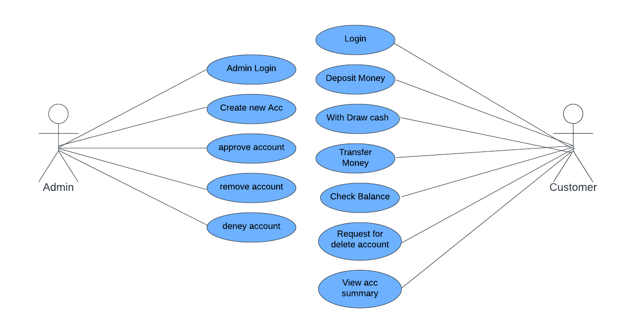

**5.2 Class Diagram**

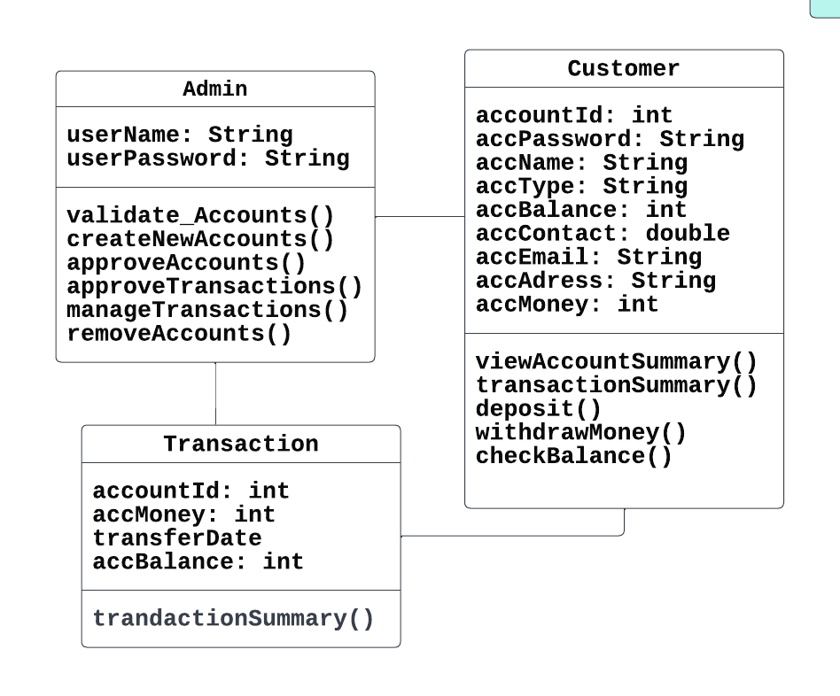

**5.3 Activity Diagram**

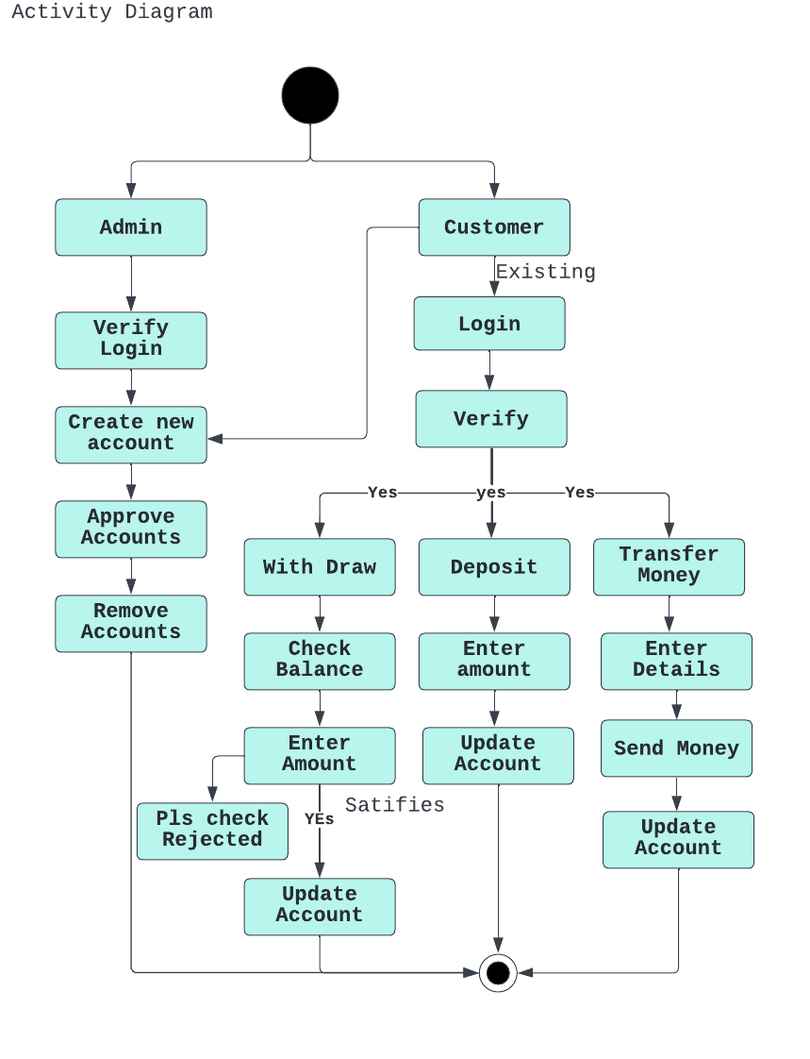

**5.4 Data Flow Diagram**

**DFD For Creating Account:**

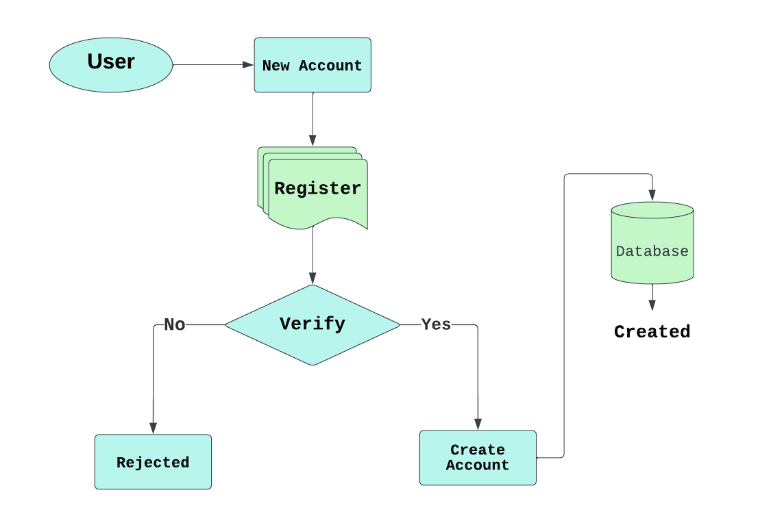

**DFD Diagram For WithDraw And Deposit**

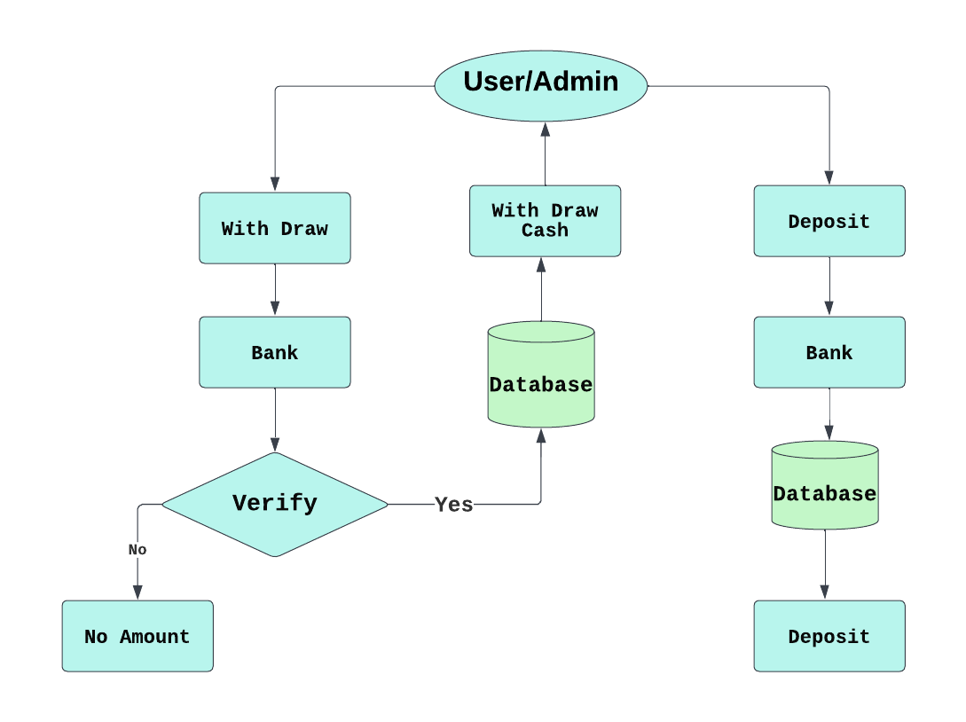

**DFD For Deleting Account:**

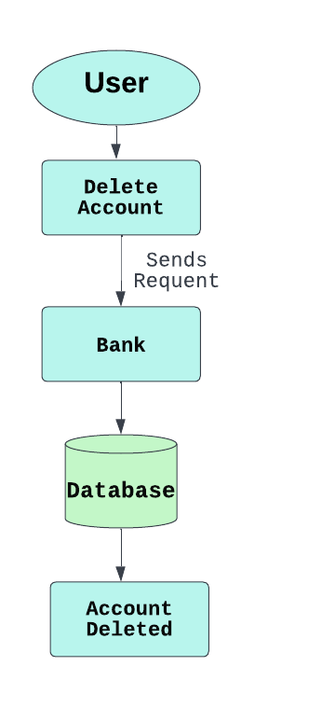

**5.5 State Chart Diagram**

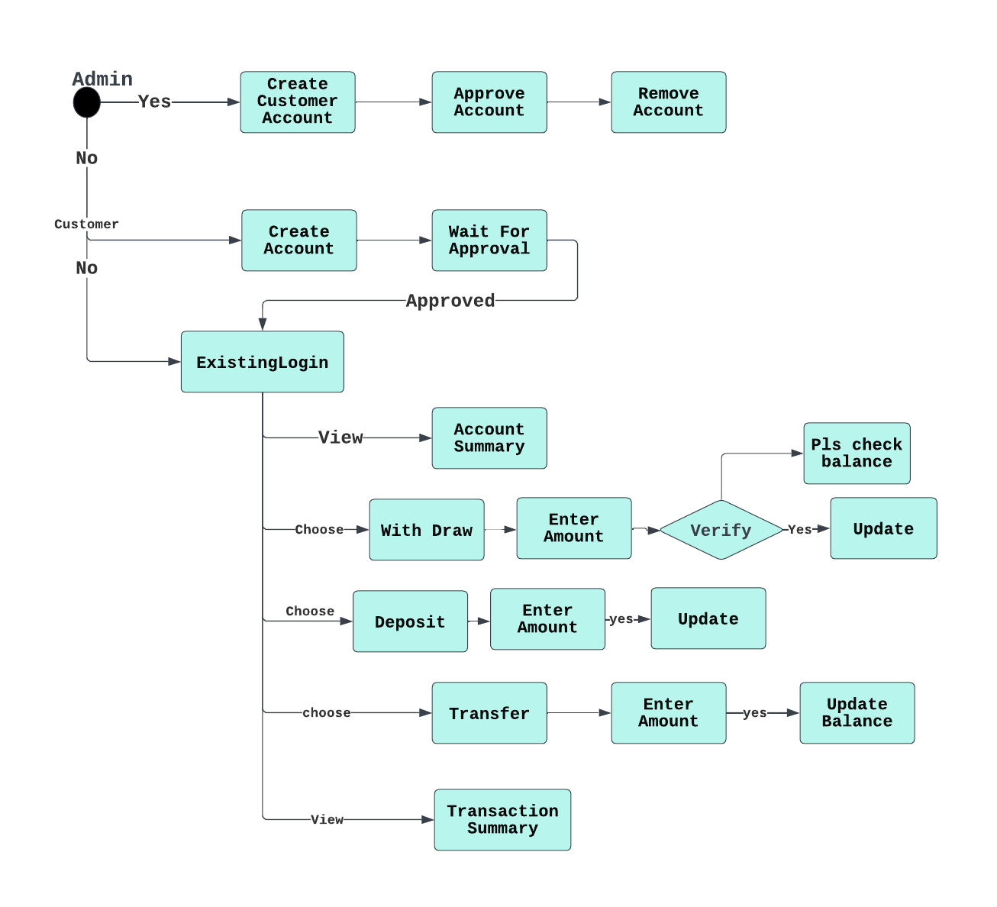

**6. Project Output Screenshots:**

**7. Conclusion**

# 